Washington University
Progress Report
Light Detection with Ultra-High Dynamic Range
DoHyun Kim, Leran Firer, and Eric Kleinberg
10/31/2012

Client: Professor Jon Silva. Washington University in St. Louis. BME Senior Design

1. Need and Specific Design Requirements .
Specialized chemical or voltage sensing domains of proteins in cells often respond to specific environmental stimuli. Until recently, it has been difficult to study and observe such proteins in action: the output of their response was typically known, but the processes were ambiguous. When the protein movements and conformational changes occurred in given light excitation, the number of photons of light stimuli through the protein is changed. By observing the amount of photons collected through the protein of interest in the given time of protein conformational change, the protein kinetics of conformational change can be modeled. This technique has been extremely constrained in the time domain. The conformational changes of protein occur in a very short time; they occur on a timescale of microsecond to nanosecond.
Our client Jon Silva currently studies channel gating via oocytes. In our client’s experimental design, a specific microscopy called fluorescence microscopy in which a floure molecule is attached into a protein molecule under light stimulus of 600nm green L.E.D. light which is used to acquire the data of calcium channel protein kinetics. The photons passed through the protein are focused through the lens and are collected into the active area of PIN diode. PIN diode is a specific type of diode that absorbs photons to elicit a current. The PIN diode generated background currents are often in range of μA in client’s experiment. Then the frequency information of protein conformation change is acquired by the changes of current over DC offset value recorded in the PIN diode generating current data of fluorescence microscopy. The currents used in frequency analysis of protein kinase in the client’s experiments are relatively small compared to the background signal. The signal of interest is at the level of pA in which the signal to noise ration of the system is approximately 0.1%. By integrating the frequency information, the model of protein kinase will be established.
The client requested the design of an integrated system of light focusing, electrical, and cooling system that minimizes the noise and amplifies this 0.1% signal fitting into adaptors of the fluorescence microscopy currently installed in the client’s laboratory.
The optical focusing system must be able to focus a laser beam with a 600 nm wavelength to a diffraction limited spot onto the smallest PIN Diode possible, so as to minimize noise. This can be achieved using many different types of lenses. Singlet lenses are simple and easy to use, but their performance is limited by spherical and chromatic aberrations, astigmatism, and other distortions. Thus, multi-element lenses, designed using combinations of singlet elements, are necessary to minimize the number of aberrations during measurement. One excellent solution is an achromatic doublet lens system, which involves two singlet lens elements cemented together to nearly eliminate the spherical and chromatic aberration components. Achromatic lenses exhibit an interesting behavior in that the shorter the back focal length (distance from the second lens to focal point), the tighter the focal spot. Dr. Silva’s parallel input ray bundle will pass through a lens having a 25mm diameter, so as to capture the entire beam. Minimizing the focal length is advantageous due to design constraints, and the smallest commercially available achromatic doublet lens with a 25 mm diameter has a focal length of 30mm.
The PIN diode must have a good responsivity at the given stimulus wavelength of 600 nm green L.E.D. beam of the client’s fluorescence microscopy. The whole purpose of the design is to reduce noise as much as possible. The PIN diode itself must have the characteristics of low thermal noise and low dark current noise. To lower the thermal noise, the diode will be cooled by the cooler attached to it. The cooling system, however, must not disturb the PIN diode operation meaning the PIN diode should have a wide temperature of operation. The size of the active area is another source of noise generation. While a smaller active area creates a lower noise environment, the PIN diode must still have an active area that is larger than the diffraction limits of the lens.
Since the input of the system is relatively small compared to the background signal (approximately ~ 0.1 %) the signal must be amplified while reducing the noise. An amplifier or a series of amplifiers is required. The output of the entire electrical system is expected to have a gain of 100 or larger.
The output of the PIN Diode is current. The current generated in PIN diode, thus becomes the primary input of the electrical system. The real OP Amps have small current flow inside of the OP Amps; thus, the current input from PIN diode induces the internal voltage error that can propagate through the whole circuit. To cancel this error, the input current must be properly biased, or be transformed as a voltage input.
The frequency response of interest in the client’s experiment is the response of 5 kHz to 10 kHz. Therefore, the electrical circuit designed must have a bandpass filter with a target bandwidth of 5 kHz to 10 kHz. The change of current generation by PIN diode is the primary indication of the protein conformation; thus, the shape of original signal, featuring the protein kinase, holds crucial information for client’s experiments. As the shape of the signal is what the client is interested in, the output signal through filters must preserve the shape of the original signal.
The electrical system will be attached next to the SM1 adaptor; however, the adaptor type can be changed if necessary due to the size limitation of the cooling system. Since all electrical components of the design costs around $1 to $60, the client’s request of overall budget of $1000 will be easily achieved.
The client requested that the PIN diode be cooled close to its optimal temperature as a means of reducing electrical noise. The client suggested use of a Peltier Cooler towards this end, but was open to any other solutions. There is an inherent size limitation based on fitting the cooling method with the client’s SM1 mount together with the PIN diode, though the client is open to custom adaptor designs or other off the shelf adaptors if necessary.
Table 1: Specific Design Requirements
System | Requirements
Electrical System | - PIN Diode  - Responsivity at 600nm light beam  - Low Noise  - Wide Operational Temperature range  - Minimized Active Area  - Bandpass Filter of 5 kHz to 10 kHz  - Amplifier with a gain of 100 or larger  - Attach the system next to the SM1 adaptor
Peltier Cooling System | - Peltier or other cooling method to cool PIN diode to optimal temperature (typically around -20 degrees Celsius).  - Cooling system must fit client’s Sm1 Adaptor.
Light Focusing System | - Achromatic doublet lens  - Known diameter = 25mm  - Minimized focal length  - Focus to diffraction limited spot  - Minimize optical aberrations
Cost | - 1000$

2. Light Focusing System Design .
A. Optical Aberrations
Since the lens must be able to focus the LED beam to a diffraction limited spot, the light focusing system’s main limitation lies in the significant amount of optical aberrations encountered in attempting to focus a beam to such a small area. Ideally, a perfect lens would be able to focus a parallel input ray bundle on-axis, to an infinitesimal point, free of aberrations, as shown in Figure 1. However, this phenomenon is impossible with a real lens, so first a thorough investigation of the possible aberrations was conducted.
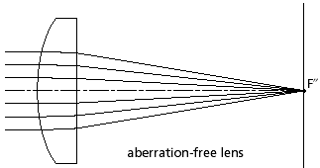
Figure 1: Aberration-Free Lens

Spherical aberration
A lens will focus rays near the edge of the bundle closer to the lens than rays closer to the axis. The distance between the paraxial focal point and the edge ray focal point is the longitudinal spherical aberration. The transverse spherical aberration is the separation between the interception points and the paraxial point, which are displaced when the edge rays intercept the paraxial focal plane. There are two factors that determine the extent of spherical aberration, lens shape and material index. A smaller index of refraction results in less spherical aberration. However, for any given index of refraction, it is possible to design a “best form” singlet lens element free of spherical aberration. Making the surface of the lens aspherical will also eliminate spherical aberration, but the manufacturing of aspherical elements with glass materials is extremely expensive, and for our purposes, an achromatic doublet will be sufficient.
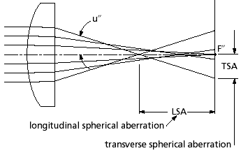
Figure 2: Spherical Aberration

Chromatic aberration
Spherical aberrations are purely a function of the shape of the lens surface, and can be observed with monochromatic light. When attempting to transform light containing multiple wavelengths, additional aberrations can arise. The index of refraction of a material is a function of wavelength, and is represented by the Abbe value of the material. Because the index of refraction is higher for shorter wavelengths, shorter wavelengths are focused closer to the lens than longer ones. Longitudinal chromatic aberration is the axial distance from the nearest to the farthest focal point. Due to the variance in index with wavelength, blue light, for example, is refracted more strongly than red light, and thus their rays will intercept the image plane at different heights. Magnification is dependent on color, and so lateral color is very dependent on the system stop location. In the case of spherical aberration, positive and negative elements have opposite signs of chromatic aberration. Chromatic aberration can be partially corrected by combining elements of nearly opposite aberration to form a doublet. Implementing two pieces of glass with different dispersion characteristics is necessary for the elements to balance each other’s aberrations. Achromatic doublets are superior to simple lenses because they correct for both spherical and chromatic aberrations when focusing collimated light or collimating point sources.
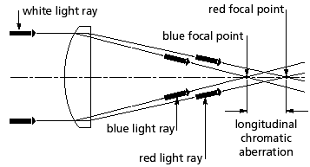
Figure 3: Chromatic Aberration
Astigmatism
When a spherical lens is used to focus an off-axis object, the natural asymmetry leads to astigmatism, and the system appears to have two different focal lengths. The plane containing both optical axis and object point is called the tangential plane, and the tangential rays are those that lie in this plane. Rays outside this plane are called skew rays. The principal ray goes from the object point through the center of the aperture of the lens system. The plane perpendicular to the tangential plane that contains the principal ray is called the sagittal plane. The tangential rays from the object come to a focus closer to the lens than do rays in the sagittal plane. When the image is evaluated at the tangential conjugate, we see a line in the sagittal direction. A line in the tangential direction is formed at the sagittal conjugate. Astigmatism is defined as the separation of these conjugates, where the image is either an elliptical or circular blur. The amount of astigmatism in a lens depends on the shape of the lens shape when there is an aperture in the system that is not in contact with the lens itself. Astigmatism strongly depends on the conjugate ratio.
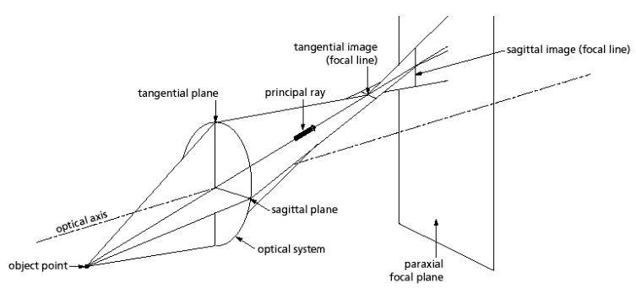
Figure 4: Astigmatism
Field curvature:
There is a tendency of optical systems to image better on curved rather than flat planes, an effect known as field curvature. In the presence of astigmatism, this problem is compounded because there are two separate astigmatic focal surfaces that correspond to the tangential and sagittal conjugates. Field curvature varies with the square of field angle or the square of image height. Therefore, by reducing the field angle by, say one-half, it is possible to reduce the blur from field curvature by a factor of four.
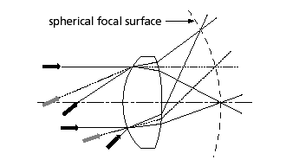
Figure 5: Field Curvature
Coma:
In spherical lenses, different parts of the lens surface exhibit different degrees of magnification, which gives rise to the aberration known as coma. Each concentric zone of a lens forms a comatic circle (ring-shaped image), which causes blurring in the image plane of off-axis object points. Even if spherical aberration is corrected and the lens brings all rays to a sharp focus on axis, a lens can still exhibit coma off-axis. Luckily, this can be corrected by using multiple surfaces or alternatively by placing an aperture, or stop, to eliminate the more marginal rays.
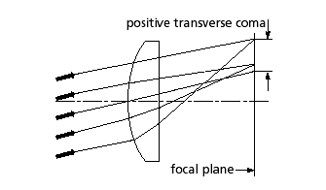
Figure 6: Coma
Geometric distortion:
The image field may also be distorted, which differs from coma. The image of an off-axis point may form at a different location than was predicted by paraxial equations. The amount of distortion increases with increasing image height, and the effect can be categorized as either pincushion or barrel. Distortion does not lower system resolution; it simply means that the image shape does not correspond exactly to the shape of the object. Distortion is the separation of the actual image point from the paraxially predicted location, expressed as either an absolute value or a percentage of the paraxial image height. A lens or lens system has opposite types of distortion depending on whether it is used forward or backward, meaning that if a lens was first used to make a image, and then reversely used to project it, there would be no distortion in the final screen image.
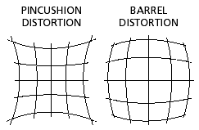
Figure 7: Geometric Distortion Types
B. Lens Alternatives
The first set of lenses is singlet element lenses and generally performs fine for simple tasks. However, for our purposes, considering the requirements of the focusing system, there would be a significant amount of optical aberrations as discussed above.

Plano-convex lens:
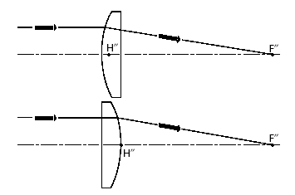
Figure 8: Plano-Convex Lens
Plano-concave lens:
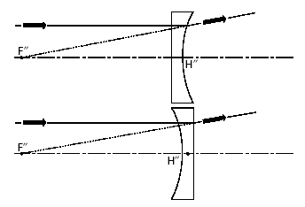
Figure 9: Plano-Concave Lens

Bi-convex lens:
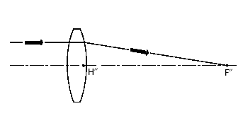
Figure 10: Bi-Convex Lens

Bi-concave lens:
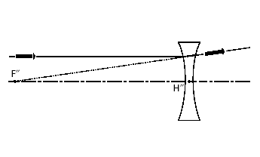
Figure 11: Bi-Concave Lens

Positive meniscus lens:
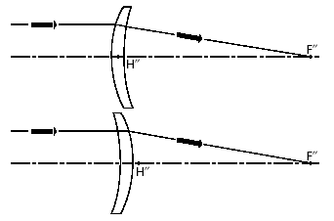
Figure 12: Positive Meniscus Lens
Negative meniscus lens:
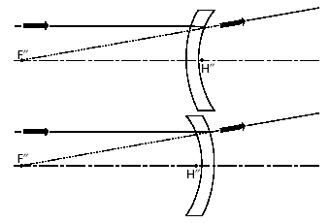
Figure 13: Negative Meniscus Lens

The second sets of lenses are multi-element lenses. Each one has unique characteristics and applications.

Symmetric lens pairs
For finite conjugate applications where both the object and the image are at a finite distance, a pair of identical lenses may be considered. If the configuration is such that the object distance and image distance are nearly equal, lens pairs provide almost perfect performance.
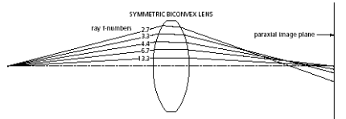
Figure 14: Symmetric Lens Pairs

Cooke Triplet Lenses
The previous lens configurations only provide improved performance on-axis, but for both on and off-axis, more complex lens forms are required. Cooke triplet is a lens form that provides good imaging performance over a field of view of ±20-25 degrees.
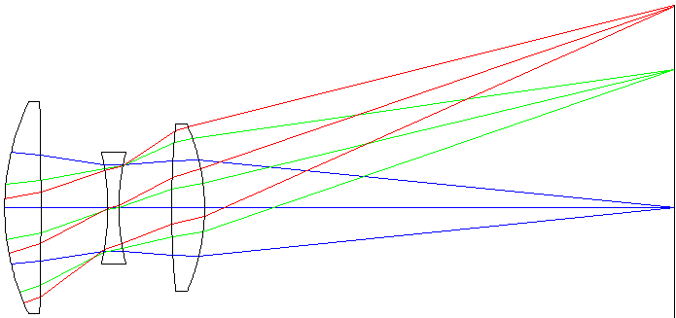
Figure 15: Cooke Triplet Lenses

Double Gaussian Lens
To achieve higher image quality and to increase the relative aperture over a Cooke triplet, a Double Gaussian lens can be used. The double Gaussian design uses two cemented doublets and two companion singlet elements. This lens offers excellent performance over a significant field of view.
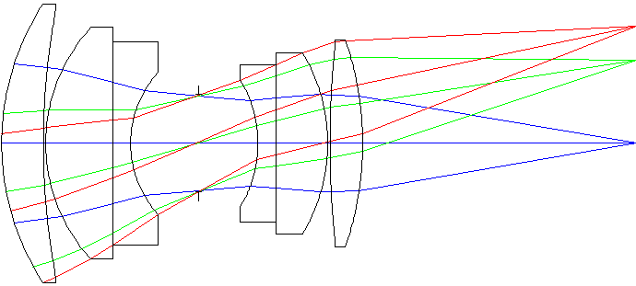
Figure 16: Double Gaussian Lens

Reverse Telephoto Lens
A reverse telephoto lens is used when more field of view coverage is necessary. The front lens group has a negative power while the second is group is positive. This is so that the input field of view is reduced. This configuration allows the field of view to be increased ±35 degrees. An interesting, advantageous quality of this configuration is that the system’s back focal length can be longer than the effective focal length, making it very attractive to short focal length lenses.
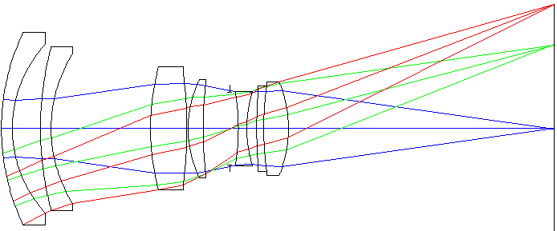
Figure 17: Reverse Telephoto Lens

Wide-angle “Fisheye” Lenses
Wide-angle "fisheye" lenses are typically used in security or surveillance scenarios, requiring a significant number of components. However, there is significant distortion associated with these lenses.

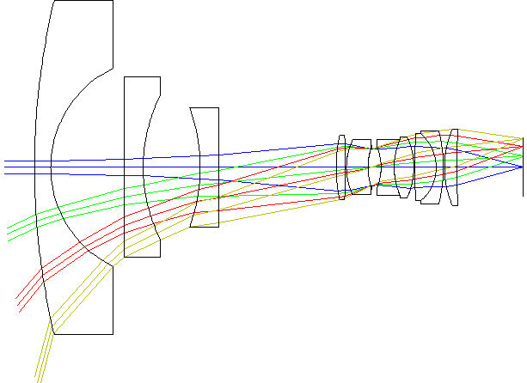
Figure 18: Wide-Angle Lens
C. Actual Design
An achromatic doublet lens will be used in the light focusing system.
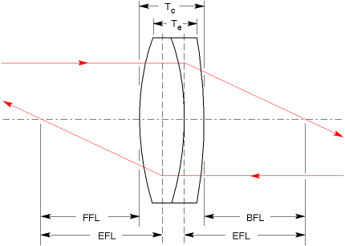
Figure 19: Achromatic Doublet Lens
An achromatic doublet is made of two singlet lens elements combined as one unit. The lens’s performance advantage is its ability to completely eliminate the spherical and longitudinal aberration when focusing light to a diffraction limit. They do however, have some major limitations. First, their off-axis performance deteriorates rapidly with the field of view, and secondly, the f/# of achromatic doublet lenses are limited to about f/3 or higher. Luckily these limitations are not detrimental to the performance or design of the optical system in this situation. The specifications of the achromatic doublet lens being implemented in the design can be found in Table 2.
Table 2: AC254-030-A Achromatic Doublet Lens
Back Focal Length REF (mm) | 22.2
Centration (arcmin) | <3
Clear Aperture (% of diameter) | >90
Design Diameter (mm) | 25.4
Design Wavelength (nm) | 486.1 | 587.6 | 656.3
Diameter Tolerance (mm) | +0.0/-0.1
Focal Length (mm) | 30
Surface Quality | 40-20 Scratch-Dig
Thickness Tolerance (mm) | ±0.15
Weight (kg) | 0.04

The diffraction limit equation for calculating the radius of the airy disk formed by an A-sphere lens:
$$r=\frac{2}{π}λ\frac{f}{D}$$
However, as previously mentioned A-sphere lenses are extremely expensive, and unnecessary for our purposes. A constant is implemented to account for this (achromatic doublet).

$$r=\frac{2}{π}λ\frac{f}{D} →→ r=\frac{2*C}{π}λ\frac{f}{D}$$

Using the modified equation, with specifications from Table 2, one arrives at the radius of the airy disk formed, and finally the area of the diffraction limited spot formed on the PIN diode.

$$r=\frac{2*C}{π}λ\frac{f}{D}=\frac{2*2}{π}(0.6µm)(\frac{30mm}{25mm})$$

$$r=0.916 µm$$

$$A=πr^{2}=2.64 {µm}^{2}$$

r: radius of Airy disk formed
λ: wavelength of LED beam
C: constant accounting for non-spherical lens
f: focal length
D: diameter of entrance pupil of imaging lens
A: area of diffraction limit spot

3. Electrical System Design .
A. PIN Diode Selection
Since the L.E.D. light of excitation is 600 nm, the PIN diode must have good responsivity at 600 nm wavelength. As the noise to signal ration of the system is quite high, the noise generation by the PIN diode must be minimized. The thermal noise is another critical source of noise since the signal of interest is the level of pA; therefore, the PIN diode must be able to operate normally in a cooled environment to lower noise. The size of active area of PIN diode must be based on the diffraction limits of the lens for acquiring a maximal signal within minimal size.
A Pugh Chart analysis was performed based on the criteria set above. A smaller active area is required to minimizing noise generation. The focal length calculation performed showed that the focal length of the light focusing system is 30 mm and its matching active area on the PIN diode is 2.64 μm². Since the matching active area of PIN diode calculated is much smaller than the active areas of commercially available PIN diodes, PIN diodes with smaller active areas get higher scores.
Table 3: Pugh Chart for PIN Diode
 | Weight | PIN_10AP | PIN_10DP(I)/SB | PIN_APD032 | PIN_FD07 | PIN_FD15 | PIN_HR(s)008(L) | PIN-RD100(A)
Ultra Low  Noise | 10 | 10 | 10 | 10 | 10 | 10 | 10 | 10
Low Capacitance | 8 | 0 | 0 | 10 | 10 | 10 | 10 | 10
Temperature Range | 5 | 6 | 6 | 10 | 9 | 9 | 9 | 7
Responsivity at 600nm | 9 | 7 | 8 | 6 | 6 | 6 | 7 | 9
Diode Activation Area | 8 | 9 | 9 | 5 | 6 | 5 | 9 | 3
High Speed Circuit | 4 | 0 | 0 | 2 | 2 | 2 | 2 | 2
 | Total | 265 | 272 | 322 | 335 | 327 | 368 | 320

Table 4: PIN Diode Specifications
PIN Diode Type | Ultra Low Noise | Low Capacitance | Temperature Range (ºC) | Responsitivity at 600nm (A/W) | Activation Area (mm²) | High Speed Circuit
PIN_10AP | ✔ | X | 0 – 70 | 0.27 - 0.4 | 100 | X
PIN_10DP(I)/SB | ✔ | X | -10 – 60 | 0.33 – 0.4 | 100 | X
PIN_APD032 | ✔ | ✔ | -60 – 100 | 7.5 @ 850nm | 0.5 | ✔
PIN_FD07 | ✔ | ✔ | -40 – 100 | 0.3 | 7.1 | ✔
PIN_FD15 | ✔ | ✔ | -40 – 100 | 0.3 | 14.9 | ✔
PIN_HR(s)008(L) | ✔ | ✔ | -40 – 100 | 0.32 | 0.04 | ✔
PIN-RD100(A) | ✔ | ✔ | -20 – 60 | 0.4 | 100 | X

With the highest score of 368 points, PIN-HR(S)008(L) is selected to be used in this project.

Table 5: PIN-HR(S)008(L) Information
Product Used in Design | PIN-HR(S)008(L)
Manufacturer | UDT Sensor. Inc  Phone: 310) 978-0516  http://www.udt.com
Price | $22.00 to $246.00**  (Price varies by the additional options)
Size | Diameter = 0.018 ± 0.002”  Height = 0.0625” (Body + Wire)  = 0.0125” (Body)
Quantity Required | 1
Picture of the product | 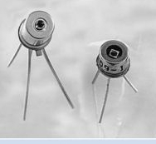

B. Input Constraint Design
Why is Input Constraint Design required?
The source for the electrical system is the current generated in the PIN diode. Since the OP Amp in reality has current flow through the transistors inside of it, the current flowing times the internal impedance of the OP Amp will cause a voltage by Ohm’s Law. This is an error voltage between the real signal and what the OP Amp recognizes which becomes an effective offset error which propagates through the circuit. To cancel this error voltage, two techniques can be used: Input Biasing and Current to Voltage Source Converter.

Possible Solution – Input Biasing
Lowering the resistance will generally minimize the error since the current flow of OP Amps is ranged from μA to pA. By installing a bias current, one can find out the resistance values that can cancel the error by following the below calculations. Choosing R3 equal to the parallel combo of R1 and R2, and the bias current errors will be canceled.
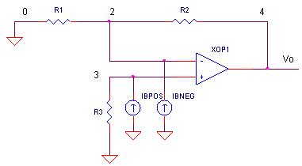
Ib = Input Biasing Current (μA to pA)

However, since the input current of the system is at a level of pA, the current biasing with variable resistance requires the user changing the resistance value for acquiring corresponding input biasing current. This process can be very troublesome for the client. Also as the current becomes the primary input source of the electrical system, all signal responses and outputs must be calculated as current. The current flowing through, however, can be added and subtracted by other power sources, tracking current information will be require extra analysis.

Possible Solution – AC Current to Voltage Converter.
Typical converters use resistances and inductances to transform current to voltage; however, this type of converters usually converts current sources of μA to mA to voltage sources. A literature paper, “A low-noise and wide-band ac boosting current-to-voltage ampliﬁer
for scanning tunneling microscopy” written by Dae-Jeong Kim describes the technique of converting pA current to voltage source with unity gain. The designed circuit in literature was used for tunneling microscopy which has a current output level of pA to nA.
By using a converter, a current source can be transformed as a voltage source that has minimized current flow to the electrical system. Minimized current induced lower voltage error generated inside of OP Amps. Also as the primary input of the electrical system becomes voltage, tracking down voltage output values are relatively easy compared to tracking down current outputs. Since the conditions of experiments in literature and of experiments by the client are very similar, the converter design from the literature was adopted.

Actual Design
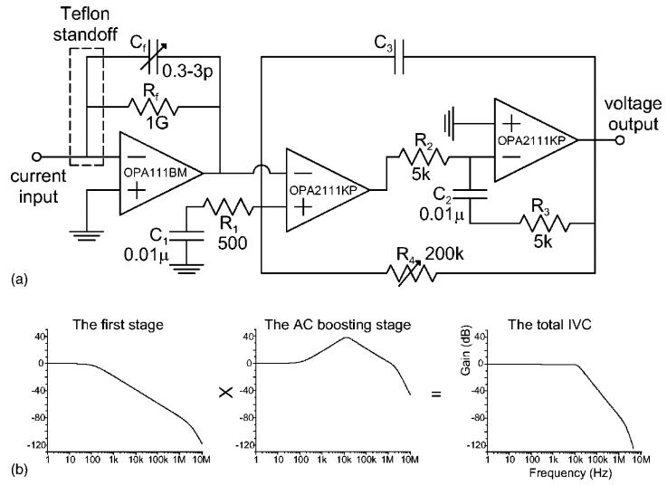
Figure 20: (a) The circuit diagram of two stage ac boosting IVC. (b) The gain response of ac boosting
IVC

Table 6: The bandwidths of the ac boosting IVC tuned by different C3 values, and the corresponding noise characteristics
C3 (pF) | Bandwidth (kHz) | Noise (pA)ª | Noise (pA)^{b}
100 | 11.3 | 2.25 | 4.55
220 | 5.4 | 1.29 | 2.69
470 | 2.4 | 0.75 | 1.37
1000 | 1.2 | 0.47 | 0.73
1500 | 0.76 | 0.40 | 0.58
ª rms values with the input open.
^{b} rms values with the input capacitance of 100 pF.

The design adopted has a unity gain property for the range of 1Hz to 10 kHz (see Figure above). Since the frequency band of interest of client is 5 kHz to 10 kHz, the design adopted didn’t distort the signal of interest. For choosing value of C3, since our input is level of pA, noised added by the converter is needed to be minimized. On the other hand, the bandwidth of the system must be wider than 5 kHz. Therefore, a 220 pF capacitor is chosen to be used for C3 of the design adopted.
Table 7: Product Information of Design Requirement
Product Used in Design | OPA111BM | OPA2111KP | Tefalon Standoff –  PTFE Insulated Terminal Pins
Manufacturer | Burr Brown Corp.  Phone: 520) 746-1111  http://www.burr-brown.com | Burr Brown Corp.  Phone: 520) 746-1111  http://www.burr-brown.com | Keystone Electronics. Corp http://www.keyeleco.com
Price | $53.35 | $15.23 | $1.00 ~ $4.00
Size | 9.08 x 9.08 x 4.4 mm³ | 9.3 x 6.5 x 6.6 mm³ | Not determined yet
Quantity | 1 | 1 | 1
Picture of the Product | 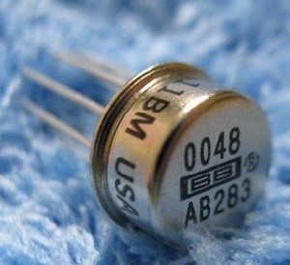 | 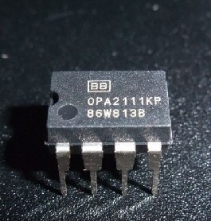 | 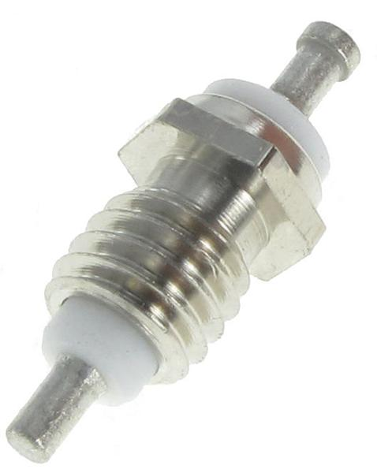

C. Bandpass Filter Design
Why is a bandpass filter required?
The client’s fluorescence-microscopy research of protein kinases is mostly concerned with the frequency response of 5 kHz to 10 kHz. To maintain the data with minimized noise, a band pass filter with a bandwidth of 5 kHz to 10 kHz is required. Commonly used bandpass filter types are passive, active Bessel filter, active Butterworth filter, active Chebyshev filter, and digital filter. Each type of bandpass filter has its own strengths and weak points.
Since fluorescence-microscopy researches uses the changing of current as the source of protein kinase detection, the shape of the signal observed during protein kinase conformational change is a critical component of such studies. Therefore, signals the original signal structure must be maintained, even after the filtering process.

Passive Bandpass Filter
A Passive Bandpass Filter is the easiest bandpass filter that one can design. The benefit of the passive bandpass filters is that all the components it requires are only simple resistor, inductor, and capacitor. This is very efficient in the sense of production cost. However, its downside is its frequency responses. The cutoff responses of the passive bandpass filters are not acute which means there is a loss of the gain near the cut off frequency. Also the capacitances and inductances of the passive band pass filters will distort the output signal compared to the original input signal. For example, the time constant τ = RC of the RC bandpass filter, will indicate the delay of the signal by charging and discharging voltage through the capacitors.
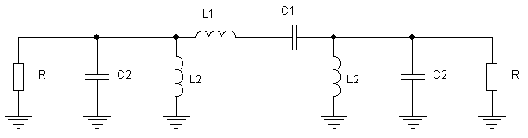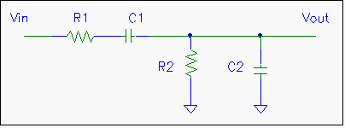
Figure 21: Passive Bandpass Filters (Right: RLC bandpass Filter, Left: RC bandpass Filter)

Digital Filters
Digital Filters are not an actual circuit, but rather a system that performs mathematical operations. To build a digital filter, a professional software developer is required. In this project, client didn’t request building a digital filter since the client has an external digital filter connected to fluorescence microscopy. The client stated that he can use the digital filter as an alternative solution if the analog filter design is failed to be achieved.

Active Filters
Active bandpass filters are bandpass filters connected to an amplifier. Amplifiers included in a filter design can be used to improve the performance and predictability of a filter while avoiding the need for inductors. Also an amplifier prevents the load impedance of the following stage from affecting the characteristics of the filter. The most commonly used active filters are Bessel, Butterworth, and Chebyshev Filters. Active filters are commonly used because of the external power source of the OP Amps that supplies power so that the output signal doesn’t lose its power, and because of their acute cutoff frequency responses compared to passive filters. Also the decay of the signal outside of the target bandwidth is relatively large. For example, a 4th order Bessel Filter has a slope of -24 dB/dec.

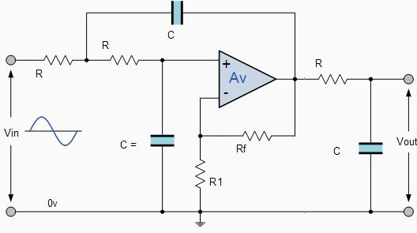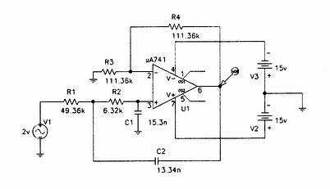
Figure 22: 3rd order Active Butterworth Filter, and 2nd order Active Chebyshev Filter
Sample responses of 8 pole filters, namely the Bessel, Butterworth, and Chebyshev (in this case of 0.5 dB ripple) are compared in the figure below. The responses have been normalized for a cutoff of 1 Hz. Comparing Figures below, it is easy to see the trade-offs in the response types.
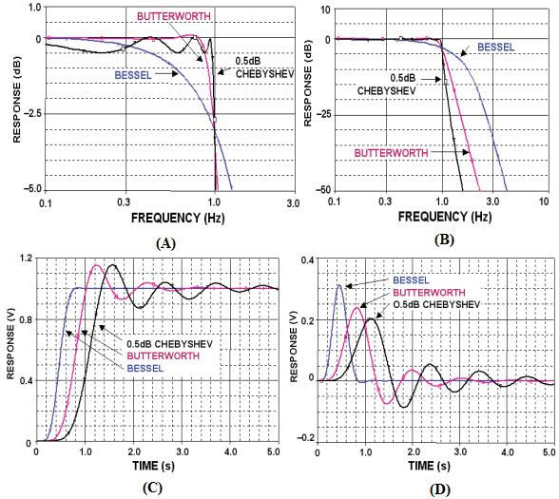
Figure 23: Comparison of Bessel, Butterworth, and Chebyshev Filters:
(A & B) amplitude response (C & D) step and impulse response

Since a Bessel Filter has the characteristic of preserving original signal characteristic as shown in the figure above, it’s chosen to be used in the design.

Actual Design
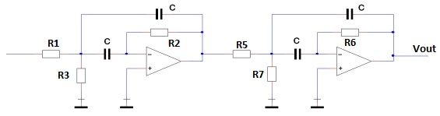
Figure 24: 4th order Bessel Bandpass Filter Schematics
Actual Calculations
- Center Frequency FM= 7.5KHz
- Bandwidth B= 5kHz
- Q= FM/B = 1.5
- Center Gain Km = 1 (absolute value); it is a unity gain filter
- From the Coefficient of the 4th order Filter Table a1 = 1.3617
b1 = 0.6180
α = 1.2711 (at Q = 1.5)
- Fm1 = FM/ α = 5900.4
Fm2 = FM* α = 9533.3
- C = 10 nF

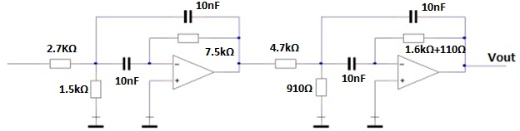
Figure 25: 4th Order Bessel Bandpass Filter Designed with Commercially Available Resistors and Capacitors
Table 8: Product Information of Design Requirement
Product Used in Design | OP Amp 741
Manufacturer | Texas Instruments .Inc  Phone: (512) 434-1560  http://www.ti.com/
Price | $0.10 ~ $ 0.15
Size | 7.112 x 10.15 x 6.857 mm³³
Quantity | 2
Picture of the Product | 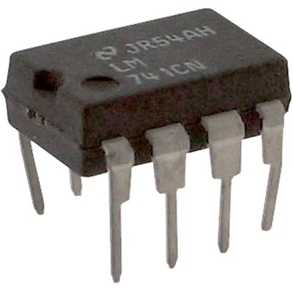

Simulation of the Design.
A Multisim simulation for the designed 4th Order Bessel Bandpass Filter was performed. A random noise with a sample rate of 500000 was generated for 10 seconds. This random noise was filtered through the designed 4th Order Bessel Bandpass Filter.
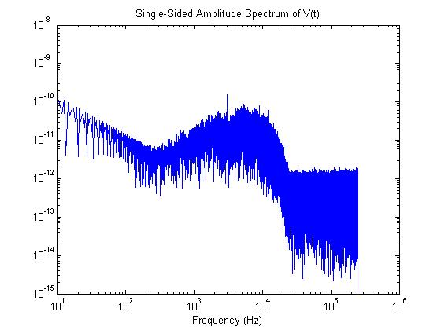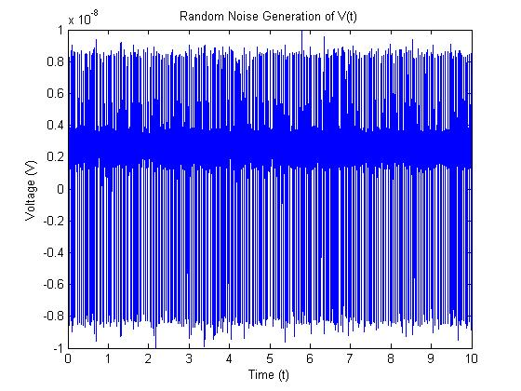
Figure 26: Random Noise Generated
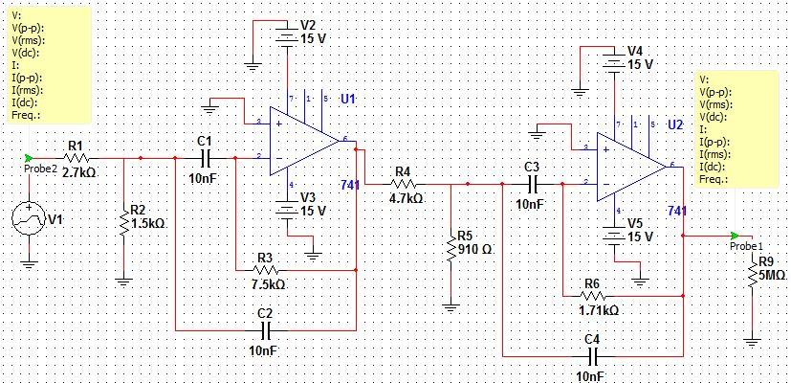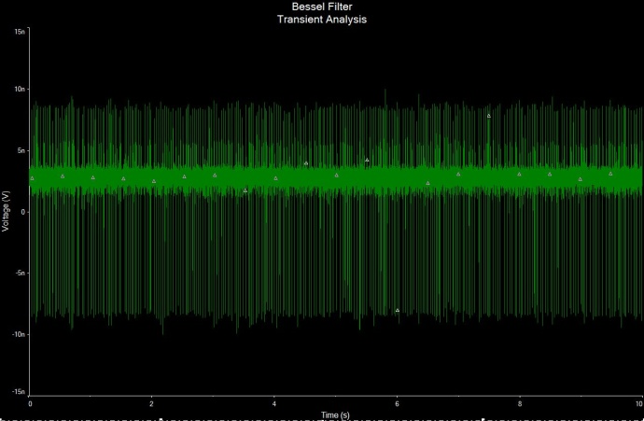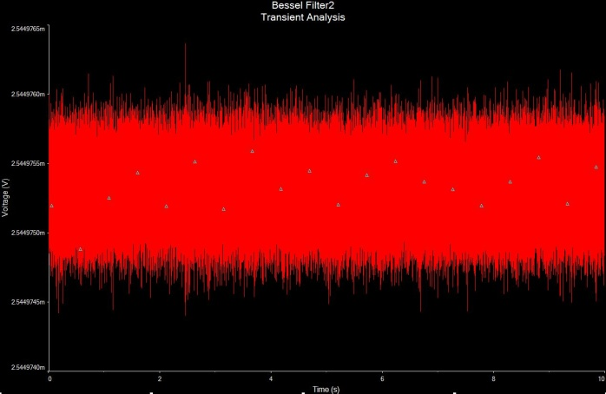
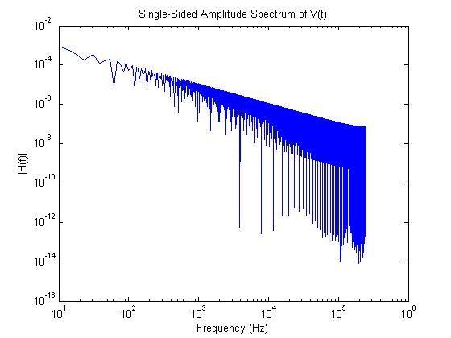
Figure 27: 4th order Bessel Filter Simulations

The Multisim simulation of the designed 4th order Bessel Filter shows the transient response of the filter. Unexpectedly, the gain of the system is 10⁶ while the gain of the system was designed to be a unity gain. Also the bandpass filtering with a bandwidth of 5 kHz to 10 kHz function is failed. It instead works as a low pass filter with a cutoff frequency near 10 Hz. As the simulation of the designed filter failed, the designed filter is under the trouble shooting process. If the system keeps failing, an alternative solution, i.e. Digital Fitler, will be used.
D. Amplifier Design
Why is an amplifier required?
Since the input of the system is relatively small compared to the background signal (approximately ~ 0.1 %) the signal must be amplified while reducing the noise. An amplifier or a series of amplifiers is required. The output of the entire electrical system is expected to have a gain of 100 or larger.
Three types of amplifiers are commonly used: OP amps, Diode Amplifier, and Transistor Amplifier. Operational Amplifiers are most commonly used since these are very easy to build and relatively cheap compared to other types of amplifiers. Operational Amplifiers can be enhanced in function by designing Differential Amplifier, Instrument Amplifier, and other else. The diode amplifier is an amplifier that has a diode connected into the amplifier to enforce the input current flow in a certain direction. This is irrelevant to the amplifier design of the client’s request. The third type of amplifier is a Transistor Amplifier. Transistor Amplifiers have a benefit of DC biasing; therefore, their output signal can be a purely amplified frequency response of the input signal. Since the study of fluorescence microscopy is decoding frequency response of the input current, DC biasing function of the amplifier was very attractive. Therefore, a transistor amplifier was chosen to be used in this project.

Actual Design
From Sdera/Smith, MicroElectronic Circuits, 6Ed, Oxford University Press, 2011. Ch.5, P.432- P.450, the common source MOSFET transistor amplifier with a single power supply implemented design was adopted. The MOSFET transistor of the design has a property of kp = 2.0e-5 and dimensions of 100μm x 100 μm (Length x Width).
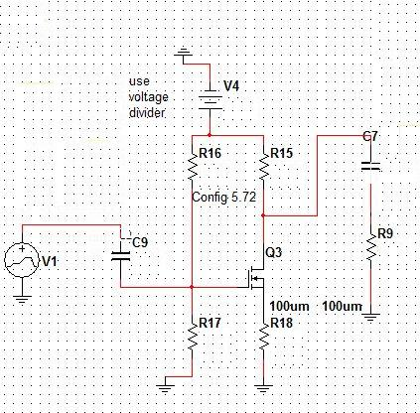
- DC Biasing
– no signal through capacitance => wire with capacitances becomes open circuits.
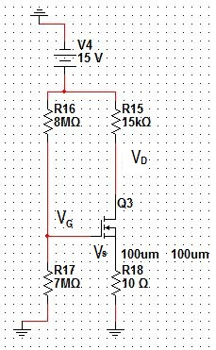
Figure 28: DC Analysis

- AC Analysis
– no DC power supply in the circuit.
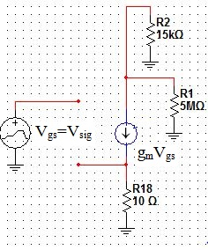
Figure 29: AC Analysis
Simulation
With the random noise generated previously, a multisim simulation of the designed transistor amplifier was performed. The simulation demonstrated that the transient response of the amplification was a gain of 2.991 with a phase shift of 180º. Since our target gain of the design was 100 or larger, two possible designs will be added in the amplifier. A cascading series of transistor amplifiers, or an OP amp attached to the current design will result the increased gain as high as the target gain.
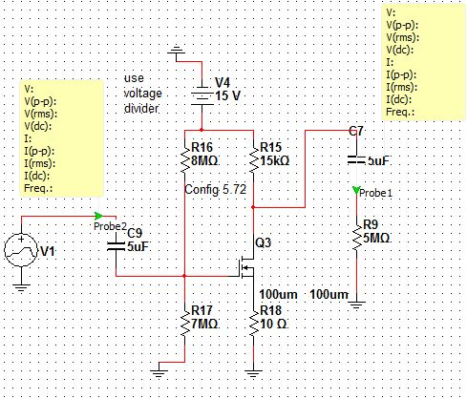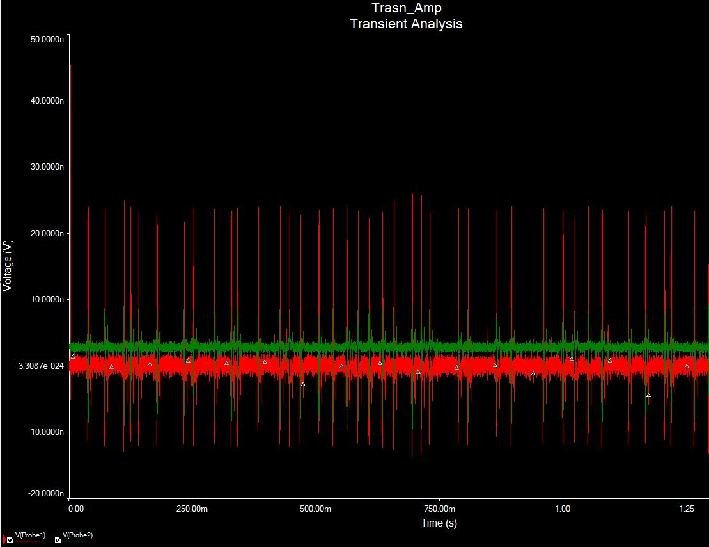
Figure 30: Multisim Simulation of the Designed Transistor Amplifier
4. Cooling System Design .
A Survey of Cooling Methods:
Several alternatives exist to the thermoelectric cooling suggested by the client, each with their own advantages and disadvantages. Cooling methods primarily rely on fluids (either in enclosures or in open systems) which act to transport heat. More advanced methods utilize thermoelectric effects. The simplest cooling method is open air cooling.
Open Air cooling involves increasing the flow of air in the surrounding region of the circuit to be cooled by employing a fan. Air cooling would not suffice in the light detection system for several reasons. First it is unlikely that sufficient heat dissipation could be achieved due to the small size of the PIN diode to be cooled and the low desired temperature (-20 degrees Celsius) desired. Second, it is unlikely that sufficient air flow could be achieved since the PIN diode will be narrowly embedded within the SM1 adapter. Finally there is the issue of where to place such a fan. Ideally the fan would blow directly through the hole that the PIN diode is located. If placed in front, the L.E.D. is blocked. If placed behind, it would be difficult to fit given the rest of the circuitry. Another popular open cooling design is that of open liquid nitrogen cooling.
Liquid nitrogen can easily provide enough cooling to the PIN diode, since it is capable of achieving temperatures below -100 degrees Celsius. But liquid nitrogen has certain important downsides. First, it is difficult to focus. It would not just cool the circuit, but also the surroundings. In particular it would cool the lens and possibly the specimen being viewed under fluorescence microscopy. In cooling the surroundings, it would cause condensation of water vapor from the air which would prevent the proper functioning of the lens, and potentially damage the electrical filtration system. Finally liquid nitrogen cooling systems have the complication of the Leidenfrost effect, in which the liquid nitrogen would boil upon contact with the system, producing nitrogen vapors which effectively insulate the system, decreasing the efficiency of cooling. Overcoming these downsides requires excessive use of insulation, which is exacerbated by the small area of the SM1 adapter and PIN diode combination. Liquid nitrogen is also a rather expensive cooling solution, requiring continual refills. More complex than liquid nitrogen cooling is refrigeration.
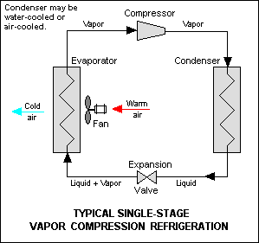
Figure 31: A Typical Refrigeration Cycle

Refrigeration involves cycling a fluid through a circuit involving a compression and an expansion phase. In the compression phase, vapor is condensed to liquid, which then absorbs heat and vaporizes in the expansion phase. Refrigeration can mean placing the entire microscope apparatus in a refrigerator, or it can mean attempting to construct a small refrigeration cycle around the PIN diode. Placing the entire apparatus in a refrigerator is untenable. It makes the microscope difficult to use, it potentially damages the electronics via condensation, and it may damage cold sensitive biological specimens. Constructing a refrigeration cycle around the PIN diode is not really feasible: such an apparatus requires much more space than is available. Even if enough space was available, custom building a refrigeration cycle would be far too costly. Clearly a common problem is size: most cooling methods are designed to cool surface areas far larger than that of a PIN diode.
The best method to cool smaller objects is to use a Peltier cooler (also known as a TEC or thermoelectric module). TEC’s utilize an effect known as the Peltier effect where the application of a voltage to a thermocouple produces a heat differential dT between the two sides of the thermocouple. One slight problem with Peltier coolers is that their ability to cool is not based on a specific temperature. Their ability to cool is ranked based based off of how much energy per unit time in watts they can transfer from their “hot” side (the side in close proximity to the PIN diode) to their cold side, also known as their Qmax. As such, calculations are usually performed according to a given thermal load, typically that of a computer chip. In this specific case, there is no such load. The PIN diode is only cooled by the ambient temperature of the surroundings. Air currents are variable, so any estimations of the thermal effect of the ambient environment will be inaccurate. The group spoke with an engineer at Tellurex, a firm which specializes in TEC’s. The engineer’s advice was to use the Peltier cooler with a size that could fit the PIN diode with the highest Qmax that can be found. The DC current powering the cooler could be increased or decreased as necessary to achieve the desired temperature of -20 degrees Celsius.
The following Pugh Chart analysis is performed based on the parameters detailed above. Since the cooler’s activity can be controlled based on the magnitude of its DC power source, the most important parameters are the dimenions A, B, and H of the cooler since the cooler must fit in the SM1 adapter with the PIN diode. In this case, smaller is better. Beyond fitting the enclosure, a high dTmax and Qmax are important as they control the limit of the cooler’s cooling capacity.

Table 9: Peltier Cooler Pugh Chart
 | Weight | C2-04-0101 | C2-06-0902R | 00801-9X30-10RU3 | C2-06-0402R | C2-04-0102 | 00301-9X30-10RU2
Qmax | 7 | 5 | 10 | 4 | 8 | 5.5 | 3
dTmax | 6 | 8 | 8 | 8.5 | 8 | 8 | 8.5
A | 10 | 7 | 6.5 | 9 | 7 | 8.5 | 10
B | 10 | 7 | 3 | 9 | 7 | 8.5 | 10
H | 10 | 7 | 7 | 9 | 7 | 8.5 | 10
 | Total | 230 | 283 | 349 | 314 | 341.5 | 372
With the highest score of 372 points, the 00301-9X30-10RU2 Single Stage Mini Peltier Cooler from Custom Thermoelectric is selected.

Table 10: Peltier Cooler Specifications
 | High Qmax | High dTmax | A dimension (smaller is better) | B dimension (smaller is better) | H dimension (smaller is better)
C2-04-0101 | X | ✔ | 4.2mm | 4.2mm | 2.6mm
C2-06-0902R | ✔ | ✔ | 6mm | 24mm | 2.3mm
00801-9X30-10RU3 | X | ✔ | 2.5mm | 2.5mm | 1.8mm
C2-06-0402R | ✔ | ✔ | 6mm | 12mm | 2.3mm
C2-04-0102 | X | ✔ | 4.2mm | 4.2mm | 2.3mm
00301-9X30-10RU2 | X | ✔ | 1.2mm | 1.9mm | 1.4mm

Table 11: Product Information of Peltier Cooler
Product Used in Design | 00301-9X30-10RU2 Single Stage Mini Peltier Cooler
Manufacturer | - Custom Thermoelectric, Inc.  Phone: (443)-926-9135  http://www.customthermoelectric.com/index.htm
Price | $25.50
Quantity | 1
Picture of the Product | 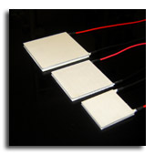
Alongside the chosen Peltier Cooler, a heat sink will need to be chosen. The heat sink functions to assist in heat transfer from the hot side of the Peltier to the surroundings. Without a heat sink, the Peltier Cooler will continuously get hotter until its circuitry is damaged or destroyed. Which heat sink is chosen is dependent on the method used to bring the Peltier Cooler into close contact with the PIN diode. The group is considering the feasibility of a custom machined enclosure for the diode and Cooler within the client’s SM1.

5. Integrated System Design .
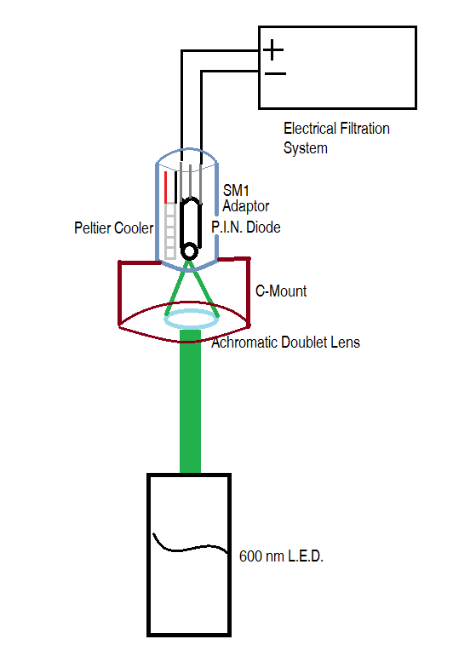
Figure 32: Schematic of Integrated System
The schematic above summarizes the overall functioning of the light detection system being developed. The 600 nm L.E.D. fires its light onto the Achromatic Doublet Lens within the C-Mount. The lens focuses this light onto the small active area of the PIN diode within the SM1 Adapter. The PIN Diode is cooled by the Peltier Cooler so as to reduce electrical noise. The electrical signal generated by the PIN diode is then amplified and filtered by the Electrical Filtration System, and then further interpreted by the client.

6. Design Schedule and Team Responsibilities .
Figure 34: Ongoing Design Schedule
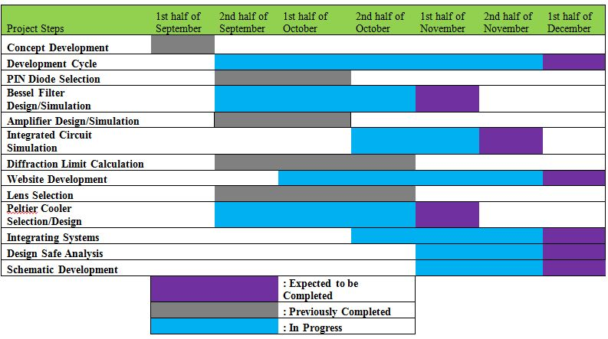

Table 12: Team Responsibilities
Team Member | Specific Role
Eric Kleinberg | - Research and Design of Peltier (TEC) Cooling System  - Website Development  - Schematic Development
Leran Firer | - Research and Design of Optical Focusing System  - Lens Selection  - Designsafe Analysis
Dohyun Kim | - Research and Design of Electrical Circuitry  - PIN Diode Selection  - Filter Simulation.

7. Bibliography .
A.J. Horne and D. Fedida, Use of Voltage Clamp Fluorimetry in Understanding Potassium Channel Gating: A Review of Shaker Fluorescence Data, Can J Physiol Pharmacol. 2009 Jun;87(6):411-8
Chris S. Gandhi, The Voltage-Clamp Fluorometry Technique, Methods Mol Biol. 2009 ;491 :213-31 18998096
Davidson, Michael W., and Mortimer Abramowitz. "Optical Microscopy." (n.d.): n. pag. Olympus. Olympus America, Inc. Web. Sept. 2012. <http://micro.magnet.fsu.edu/primer/pdfs/microscopy.pdf>.
Hank Zumbahlen, Linear Circuit Desing Handbook: CHAPTER 8 ANALOG FILTERS, Newnes February 28, 2008 ISBN: 978-0-7506-8703-4 http://www.analog.com/library/analogdialogue/archives/43-09/EDCh%208%20filter.pdf
Kim, Dae-Jeong, A low-noise and wide-band ac boosting current-to-voltage ampliﬁer for scanning tunneling microscopy, REVIEW OF SCIENTIFIC INSTRUMENTS 76, 023703 (2005)
Kugelstadt, Thomas. "Chapter 16: Active Filter Design Techniques." Op Amps for Everyone. Amsterdam: Newnes/Elsevier, 2009. 16-1-6-66.
Overclockers. “Peltier Stacking.” Web. http://www.overclockers.com/peltier-stacking/ Sigworth, F.J. “Chapter 4: Electron Design of the Patch Clamp.” Single-Channel Recording, B. Sakmann, E. Neher (eds.), DOI 10.1007/978-1-4419-1229-9_4, © Springer Science+Business Media, LLC 2009
Sdera/Smith, MicroElectronic Circuits, 6Ed, Ch.5. Oxford University Press, 2011.
Sunex. "Achromatic Doublet." Optics-Online. N.p., n.d. Web. http://optics-online/ach.asp.
Sunex. "Lens, Lens System and Optical Aberrations." Cartage. N.p., n.d. Web. <http://www.cartage.org.lb/en/themes/sciences/physics/optics/Optical/Lens/Lens.htm>.
Tellurex. “Frequently Asked Questions About Our Cooling And Heating Technology.” Web. http://www.tellurex.com/technology/peltier-faq.php
Tellurex Enginer. Personal Interview. 28 October. 2012
Thor Labs. "Visible Achromatic Doublets." THORLABS. N.p., n.d. Web. <http://www.thorlabs.de/newgrouppage9.cfm?objectgroup_id=120>.
V-Infinity. “Peltier Application Notes.” Web. www.cui.com/Product/Resource/peltier_application_notes.pdf

